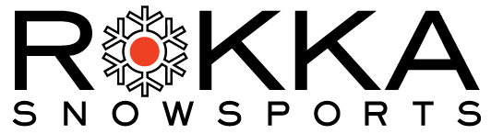

2021-2022

Name: First______________________ Last: _____________________

Age (if under 18) _________ Birthdate:_____________________

(Min Age Instructor 14, Cadet/TA 13) (For PSIA )

Address: __________________________________________________

City: _________________________________

Zip: _________________________________

Contact Information -

e-mail: ______________________________

Phone/Cell: __________________________

Other: _______________________________

Language: English ___ Japanese___ Bi-Lingual ___ Other__________

Teaching Experience:
Ski Instructor ____ no of years (approx.)

PSIA Certification Level ____

Cadets and Teaching Assistance –Indicate preference or Experience
Cadet (instructor in training) ___
Teaching Assistant (TA) ___

Comments/Goals:

